Applications will be accepted April 1 to June 15 annually

Dear Volunteer Applicant,

Thank you for your interest in becoming a volunteer counsellor at the Community Counselling Centre at Esquimalt Neighbourhood House (ENH). Becoming a volunteer counsellor at ENH involves two parts:

- Successfully completing our 10-month volunteer counsellor training;
- Committing to providing 200 hours of volunteer counselling upon successful completion of the training.

Please note that the volunteer counsellor training is part of an overall volunteer commitment, not a stand-alone program; ENH is training volunteers to provide much needed counselling services to the clients we serve. Our program is structured this way so that ENH can continue to offer free, accessible, quality counselling services to people in the Greater Victoria area.

To be really clear, this program exists, first and foremost, to provide counselling services to our community. Even though we provide a solid training component, as well as build in supervision and support for our counsellors, our mandate is not about furthering people’s personal academic/career objectives. If you want to join us to genuinely offer volunteer counselling services, please apply. If your interest is an individual focus on how to best reach your career goals, please do not.

This is an extensive volunteer commitment that typically takes people several years to complete. We hope that the volunteering can be an ongoing and dynamic engagement with community, rather than an obligatory contract to complete. Before applying, seriously consider what you are looking for in a volunteer position and whether or not you are willing and able to make the commitment required for this position. It is indeed rewarding and challenging work that makes a real difference in the lives of the people we serve!

The following application allows us to know more about you, your experiences, your skills, etc. It helps us to understand better how you might fit as a trainee, volunteer, and counsellor in our program. While we ask questions about things such as employment, we do not ask with one particular “ideal” answer in mind - we value many different assets. Indeed, we want to emphasize how important diversity, lived experiences, and equity are at ENH. People of all different backgrounds, experiences, and identities are heartily encouraged to apply.

Our volunteer counsellor training combines experiential learning and personal exploration with skills-based training and theory. The group training will be held every Wednesday evening from 6:30 to 9:30pm from Wednesday October 4th, 2023 to Wednesday June 5th, 2024, with four (4) additional Saturday or Sunday training days from 10:00am to 4:00pm.

The training also includes co-counselling (starting in December) and supervision components––these are additional time-commitments that take place outside of weekly night group time. *Please review the details of the time commitments in the Frequently Asked Questions (FAQs) before you prepare this application.

Our volunteer counsellor training will be facilitated by Julie Higginson, (her biography is in the FAQs section). Julie will be joined by other experienced ENH volunteer counsellors to create a diverse co-facilitation team.

The deadline for volunteer applications is June 15th. We will accept applications after the deadline if we have not filled all spaces. Interviews will be held over several months—June, July and August. Our plan is to try to confirm all spaces with successful applicants, as well as a training wait-list, by mid-August.

Thanks again for your interest in becoming a volunteer counsellor at ENH. If you have any questions, please do not hesitate to call me at 250-360-0644 or email me at bmacevicius@enh.bc.ca.

Sincerely,
Brenda Macevicius

Brenda Macevicius, MSW, RSW
Counselling Services Coordinator

Community Counselling Centre
Esquimalt Neighbourhood House Society (ENH)
Volunteer Counsellor Application Package

Applications will be accepted April 1 to June 15th annually.
Please return your application by June 15th to Brenda Macevicius at Esquimalt Neighbourhood House Society, 511 Constance Avenue, Victoria, BC, V9A 6N5, or fax it to: 250-384-2078 or e-mail it to: bmacevicius@enh.bc.ca.

[All information you share will be kept confidential within the Selection/Co-facilitation Team.]

Please answer the following questions on the lines provided.

Name:  Pronouns |  | Age:  (welcoming a wide spectrum of ages)
Phone: |  | Email:
Address:
Occupation:

We offer counselling support to many different people, presenting with a wide variety of concerns.
We invite you to voluntarily mention any identities, locations or communities you belong to, including Indigeneity, race, ethnicity, gender, sexual orientation, disability, sex work, immigration, mental illness, etc.

How did you hear about the ENH program? Have you applied to our program before? If so, when?

Are you applying to other volunteer counselling programs? | Yes ☐ No ☐
Do you know anyone affiliated with ENH? | Yes ☐ No ☐

References: Please give the names and phone numbers of (up to) three references who can comment on your experience as a group member and or your suitability to become a volunteer counsellor (eg. group facilitator, teacher, or supervisor).

- Name: |  | Relationship to you:
Phone: |  | Best time to call:
- Name: |  | Relationship to you:
Phone: |  | Best time to call:
- Name: |  | Relationship to you:
Phone: |  | Best time to call:

All Esquimalt Neighbourhood House staff and volunteers are required to get a current Criminal Record Check. Are you willing to do so? | Yes ☐ No ☐

Personal Background Information:

Please answer questions 1 through 20 either in the sections provided or on a separate paper.
A paragraph is adequate for most questions, some will require only a few sentences.

Please show up as yourself in these answers; we really want to begin to get to know you. In addition, you are welcome to attach a résumé but it is not required.

- What personal life experiences have you had that you consider an asset for working as a volunteer counsellor?

- Does social justice fit into your approach to volunteering/work? If so how?

- List groups (i.e. support groups, self-awareness groups, therapy groups) you have participated in. Please comment on your experiences.

4 . Life can be hard/ ever-changing, and people can be messy. Whether it’s in our own lives, in the training group, or with our clients--please comment, and say a little about how you are with messiness—such as conflicts, anger, suffering…

5. What is your experience receiving counselling (individual, couple, or family counselling, psychological or psychiatric services, or counselling from clergy?) For what, when and for how long did you receive counselling?

6. What was your experience of counselling like?

7. Please outline your educational background and training that you consider an asset for this program.

8. Please outline your employment background that you consider an asset for this program.

Counsellor Training Information:
9. What are your main reasons for wanting to participate in this 10-month training?

10. How would you participate in the training group? (i.e. what are you like as a group participant)

11. To be good counsellors, we need a high level of self-awareness. What current personal issues in your life would you like to explore in the training group?

Volunteering as a Counsellor:
12. After the training, volunteers provide 200+ hours of volunteer counselling. It usually takes 2 to 3 years to fulfill this commitment. Please tell us how this commitment would fit into your schedule and into your life in general.

13. Are there any significant life changes coming up for you that you know of (ex: starting school, re-locating, expecting a child, traveling, etc…)? | Yes ☐ No ☐

If yes, when and for what time-span?

14. Have you had experience as a volunteer? If so, where and for how long?
Two references
Name |  | Organization |  | Phone Number

15. Did you fully complete your volunteer commitment(s)? | Yes ☐ No ☐

If not, please tell us why?

16. What do you hope to gain from volunteering as a counsellor?

17. What personal strengths would you bring to your volunteer work?

18. What challenges will come up for you as a counsellor?

19. Experiences with clients will impact you. In your past and current life, how do you deal with the stresses and difficulties you face in your work/caregiving/volunteering?

20. Additional comments and questions are welcomed.

Frequently Asked Questions (FAQs)

- What do you look for in a volunteer counsellor?
- Life experience
- Relevant volunteer experience, academic experience, and or work experience and training
- Related skills, knowledge
- Diversity
- Durability, compassion, discernment, courage
- Commitment to volunteerism
- Ability to show up and be present for someone else
- Desire to contribute to community
- Good fit with a community-based approach
- Interest in being of service to others

- What are some of the reasons people seek counselling?
Often for many reasons at a time, including:
- Abuse, trauma - mental illness -marginalization
- Substance use - poverty -unstable housing
- parenting - difficult transitions -discrimination
- losses or stresses - relationship issues -multiple stresses

- What is our approach to counselling?
We have provided counselling to individuals and couples since 1995 and have earned a stellar reputation for offering high quality, accessible, client-centred counselling, which has really made a difference in people's lives. Our approach is very much informed by a social justice, structural approach to counselling, which embraces diversity and anti-oppressive practice. We see people as whole beings––mind, body, heart and spirit––living within their families, communities and the larger society, all of which have very real effects on the self and on our health and wellness. Since we value accessible counselling and do not adhere to middle-class assumptions, our services are offered for free. We don’t quiz people about their income, and we don't put people through hoops to access counselling. We do not subscribe to an "us and them" approach to counselling where counsellors are the "us" folks and clients are the "them" folks. Volunteering with us as a counsellor has a lot to do with "accompanying" people, with lots of regard for people's strengths and knowing, and embracing the heart of what it really means to sit with people's suffering.

- Who are we funded by?
We are grateful to: Community Action Initiatives, The United Way of Greater Victoria, BC Gaming, Island Health and The Ministry for Mental Health and Addictions. We also receive donations from individuals and organizations from many corners of our community, including the Provincial Employees Community Services Funds, Victoria Foundation, Seaspan Victoria Shipyards, and the Township of Esquimalt. We are always seeking funding to ensure that our services are free and accessible to our community.

- Considering counselling as a career?
We welcome applications from people who are interested in becoming professional counsellors. However, please be aware of the following:
- Our volunteer counselling program has two parts: the training and the volunteer counselling.
- Our primary purpose is to provide much-needed counselling services for people in our community.
- This volunteer experience looks great on a résumé for work or grad school. However, our program is not a small step on a ladder to a career. Please do not apply if you are on a tight time-line.
- The training component and counselling component have a great deal to offer and have assisted many people in making important decisions about how or whether they want to further pursue counselling as a career.
- *Many of the volunteer counsellors in our program do not want to be counsellors in their paid work.

- What kind of a commitment are we looking for?
- During the training:
Faithful attendance throughout the 10-month training as follows:
- Attendance at every 6:30-9:30pm evening training. As the training is “hands-on”, regular attendance is crucial. If a volunteer misses more than two evening sessions, the facilitation team may require the volunteer to leave the training.
- Attendance at all of the weekend training days
- One-to-one supervision sessions with the facilitators outside of group time--regular supervisions are encouraged.
- 10 sessions of co-counselling from December to April, including 5 sessions as a counsellor and 5 sessions as a client (some sessions involve a facilitator observing). This takes a minimum of 20 hours. Sessions occur outside of training group time, at times booked by “counsellor” and “client”. They are (generally) done off-site, often in individuals’ homes.
- Please note that while the training is not “group therapy”, self-exploration, sharing of personal experiences in group, discussing real-life issues as a “client” in a practice session, and being open to feedback are all part of the training model. By sharing our knowledge and experiences with other trainees, we can learn, develop empathy and understanding, and become better counsellors.

- During the volunteer counselling:
- A commitment of providing a minimum of 200 hours of counselling to people on our waitlist. (Volunteers can stay longer than 200 hours and often do!)
- Volunteers schedule sessions with clients in a way that works for them and their clients, i.e. in the evening, during the day, or on the weekends.
- Most volunteers see 1-3 clients a week, according to their availability and flexibility.
- Volunteers may take short breaks and return.
- Volunteers have a commitment to on-going learning, being open, being respectful, being receptive to feedback, and to resolving conflicts: hanging in there and working through challenging or awkward conversations as a responsible member of a volunteer community.
- Trainees start counselling either shortly before the training ends, or shortly thereafter.

- What is our understanding of volunteering?
- Volunteering is about contributing, caring and community.
- Volunteers are valued and respected. “Unpaid” does NOT mean unskilled.
- This is not an “us and them” approach to services where counsellors are the “us” folks and clients are the “them” folks.
- Volunteering as a counsellor has a lot to do with “accompanying” people, with lots of regard for people’s strengths and knowing.

- Reading, Exams, Evaluations and Feedback
- There are no exams and no marks are given. Participants are evaluated in ongoing, less formal ways by the facilitators and are given feedback on areas to work on.
- Readiness to see clients is assessed throughout the training.
- There is no heavy reading load required. We will distribute a reading list at the beginning of the training, which is mainly optional reading. There are also hand-outs that participants are expected to read throughout the training.
- There are occasional homework exercises given that do not require a big time commitment.
- As this is a highly experiential and integrative learning process, it requires active participation throughout the 10-month training.
- If a volunteer successfully graduates from the training, they will be invited to volunteer at our counselling centre.
- Participants’ input, feedback and evaluations are welcomed all along the way!

9. Biography of our contracted Group Facilitator:
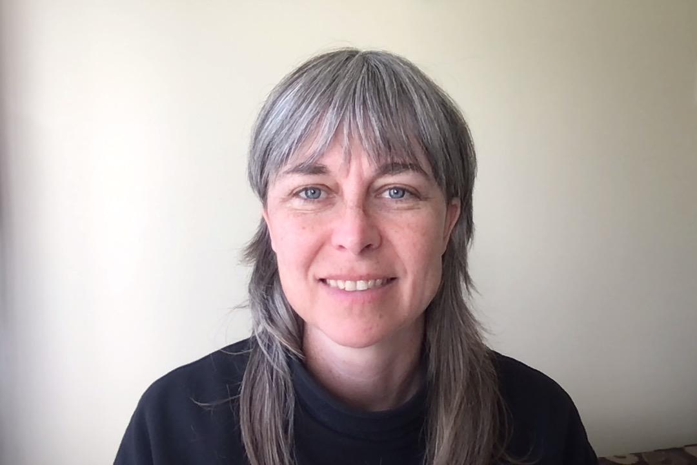
My name is Julie Higginson and I am a White settler of European ancestry. I currently reside as an uninvited guest in the unceded and traditional territory of the Lekwungen speaking Coast Salish Peoples. I want to acknowledge the historical and ongoing harms of colonial systems and to work towards a more intersectional approach to challenging power and privilege. I’m the facilitator for the Volunteer Counsellor Training program at Esquimalt Neighbourhood House. I have been involved with the ENH community since 2010, as a volunteer counsellor and a co-facilitator. I began leading the training in 2019.
As a facilitator, my hope is that group members will come to deeply know and understand themselves and others. Our identities are formed in relationship; group work and counselling are places to explore and better understand ourselves and others. Creating a container for therapeutic relationships is central to my facilitation and counselling practice. I believe that compassion, non-judgment and deep listening are essential ingredients for therapeutic relationships.
I am a master’s candidate (2023) in the Counselling Psychology program at City University of Seattle, I have a background in small business, and I led the Small Business Training program at Peers from 2014 to 2019.
Outside of work and school, I like to be outside, in the woods or on my bike. I moved to Victoria in 1996 and am grateful to live on the traditional and unceded territories of the Lekwungen people. I have a daily meditation practice and sit with both the SaltSpring Centre of Yoga community and the SaltSpring Zen Circle.

  - What does Volunteer Counselling at ENH have to offer to its volunteers?
- an opportunity to work with amazing clients and positively impact people’s lives
- 10 months of intensive, high quality counselling training
- a steep and rich learning curve
- opportunities for self-exploration and increased self-awareness
- concrete counselling knowledge and skills
- connection with a community of other wonderful volunteer counsellors
- in-depth work experience, including counselling, crisis intervention, advocacy and referrals
- ongoing support, supervision and additional training opportunities

  - What have graduates said about ENH’s Counsellor Training?

“This program far exceeded my expectations. I have never experienced such a loving, nurturing learning environment where all of me was truly welcomed.”

“From the point of view of what I learned, I can feel the differences in my daily work in how I listen and respond to clients. ... Like the rest of the group, I wish I could continue meeting every week forever!”

“I expected the program to involve great learning, but I didn’t expect it to be life-changing. But it is. I cannot believe how much personal progress I have experienced and I am so grateful.”

“I feel very lucky to have been chosen for this group and I love the work that we do. The facilitators are all wonderful, amazing people.”

“I’ve completed a Masters Degree in Counselling Psychology but the things I learned during my counsellor training at ENH gave me central tools which I still use to this day in my work with clients.”

  - What have clients said about ENH’s counselling services?

“Excellent service. I liked the ‘matching’ of the counsellor with the client, based on client needs.”

“I’m not sure that I was looking for changes or had any preconceived goals. I needed help with feeling completely overwhelmed—and I got that.”

“My counsellor’s support of me and my situation was caring, understanding, patient, skilled, compassionate and gentle.”

“She [my counsellor] gave me her complete attention, was fully accepting of me, non-judgmental, compassionate, extremely intelligent and skilled, and never gave up on me. I would highly recommend ENH to others.”

